Lab 11
Version Control System and Github
Areef ur Rahman L1f23bsse0389

Part A:
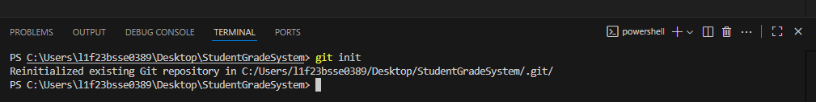
Part B:
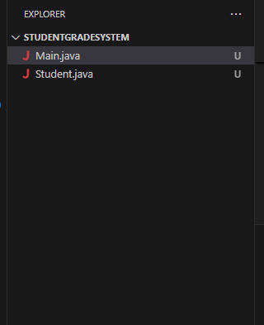
Part C:
import java.util.Scanner;

public class Main {

public static void main(String[] args) {

Scanner input = new Scanner(System.in);

try {
System.out.print("Enter Student Name: ");
String name = input.nextLine();

System.out.print("Enter Marks: ");
int marks = input.nextInt();

if (marks < 0 || marks > 100) {
throw new Exception("Invalid Marks");
}

Student student = new Student(name, marks);

String grade;

if (marks >= 80)
grade = "A";
else if (marks >= 70)
grade = "B";
else if (marks >= 60)
grade = "C";
else
grade = "Fail";

double percentage = (marks / 100.0) * 100;

System.out.println("\n--- Student Record ---");
System.out.println("Student: " + student.name);
System.out.println("Marks: " + student.marks);
System.out.println("Percentage: " + percentage + "%");
System.out.println("Grade: " + grade);

if (marks >= 50)
System.out.println("Status: Pass");
else
System.out.println("Status: Fail");

} catch (Exception e) {
System.out.println(e.getMessage());
}

input.close();
}
}

public class Student {

String name;
int marks;

Student(String name, int marks) {
this.name = name;
this.marks = marks;
}
}

Part D:
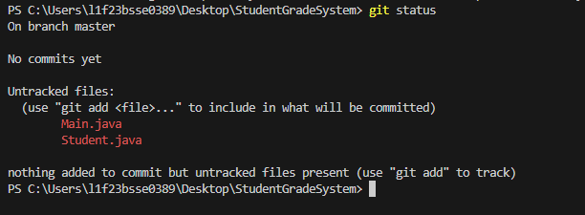

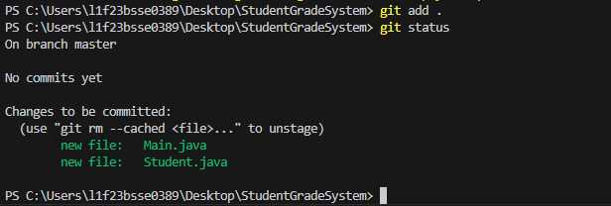

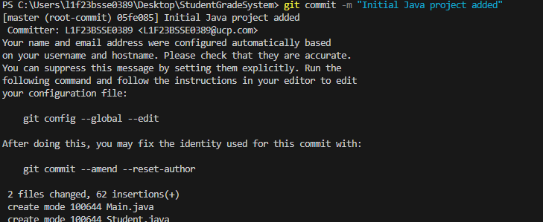

Part E:
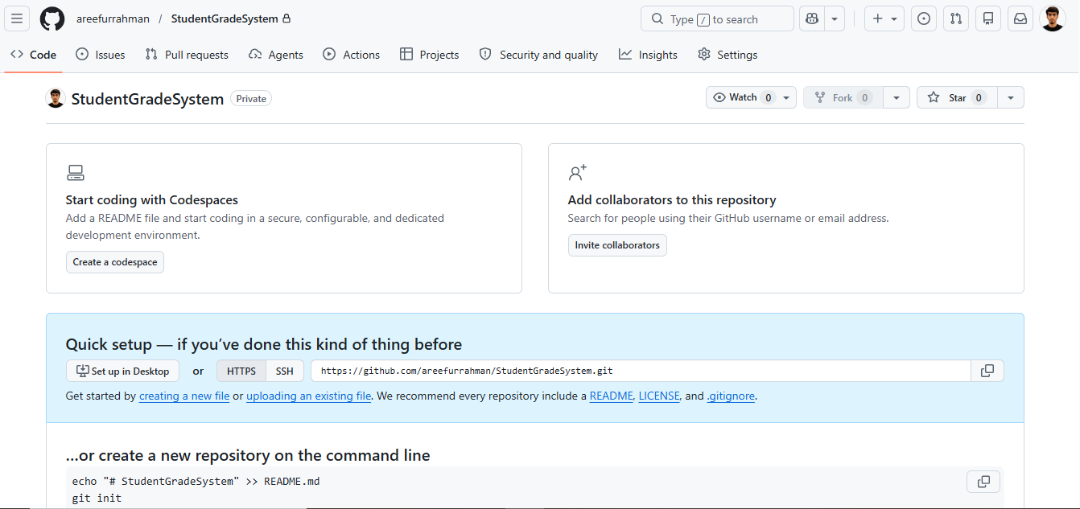

Part F:
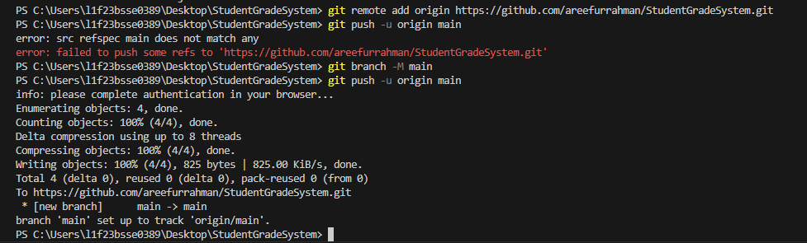

Part G:
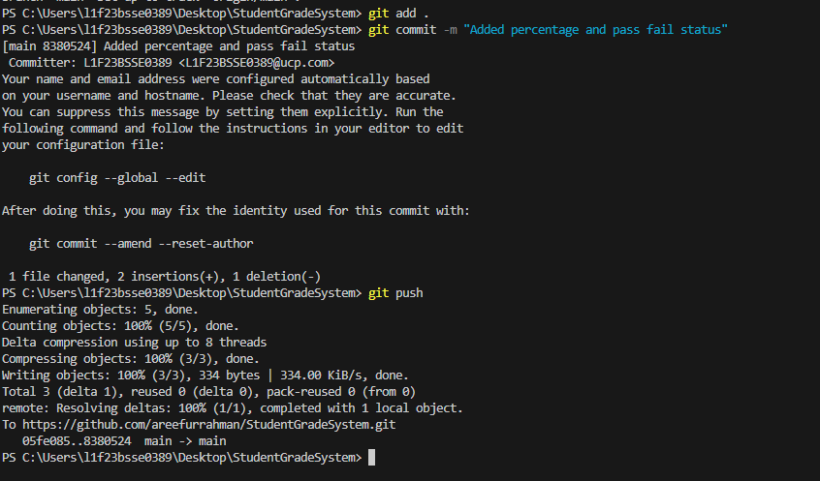

Part I:
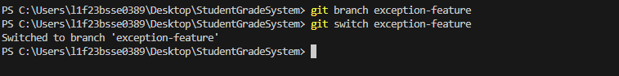
Part J:
try {

int marks = input.nextInt();

if(marks < 0 || marks > 100)
throw new Exception("Invalid Marks");

} catch(Exception e) {

System.out.println(e.getMessage());
}

Part K:
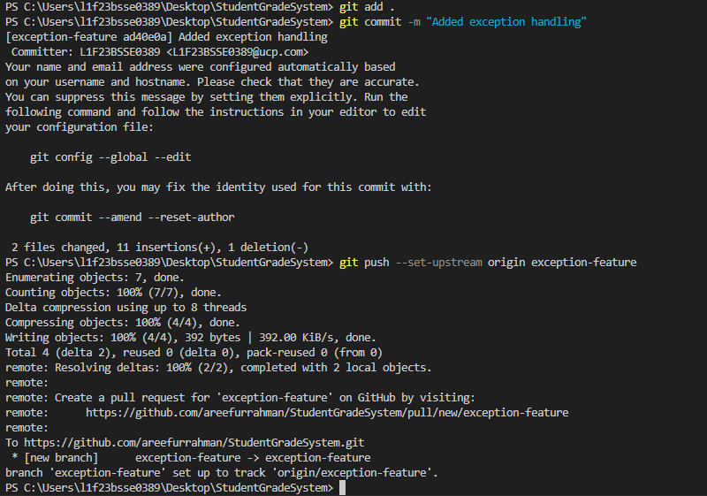

Part L:
